/*
Name: Shubham Sarang
Roll no: 1345
Unit 5: Linked list
Program: Singly Linked List
*/

#include<iostream>
#include<conio.h>
using namespace std;

//Node template
class Node
{
public:
int data;
Node *next;
};

//List tempate
class SList
{
Node *head;

public:
SList()
{
head=NULL;
}
void Insert(int x);
void Display();
void Length();
void Search(int x);
void Remove(int x);
};
// Functions
void SList :: Insert(int x)
{
//create node t
Node *t= new Node();
t->data=x;
t->next = NULL;

//first node in the list
if(head == NULL)
{
head = t;
return;
}

//traverse till last node
Node *tmp = head;

while(tmp->next != NULL)
{
tmp= tmp->next;
}
//attach t to the last node tmp
tmp->next = t;
}
void SList :: Display()
{
Node *tmp = head;
while(tmp!=NULL)
{
cout<<tmp->data<<"->";
tmp = tmp->next;
}
cout<<"End of list";
}

void SList :: Length()
{
Node *tmp = head;
int count=0;
while(tmp!=NULL)
{
count++;
tmp = tmp->next;
}
cout<<"Number of elements in list is "<<count;
}

void SList :: Search(int x)
{
Node *tmp=head;
int flag=0;

while(tmp!=NULL)
{
if(tmp->data==x)
{
flag=1;
break;
}
tmp=tmp->next;
}

if(flag==1)
{
cout<<"Element "<<x<<" found";
}
else
{
cout<<"Element "<<x<<" not found";
}
}

void SList :: Remove(int x)
{
//Step 1:List in empty return control
if(head==NULL)
{
cout<<"LIST IS EMPTY";
return;
}
//Step 2: Search element
Node *tmp = head;
Node *prev = NULL;
int flag = 0;

while(tmp!=NULL)
{
if(tmp->data == x)
{
flag = 1;
break;
}
prev = tmp;
tmp = tmp->next;
}

//step 3: unsuccessfull search return control
if(flag==0)
{
cout<<"Element "<<x<<" not found ";
return;
}

//Step 4: Successful search, a single node deletion
if(tmp == head && tmp->next == NULL)
{
head = NULL;
}
else if(tmp==head) //step 4 b: head node deletion
{
head = tmp->next;
}
else if(tmp->next == NULL) //step4 c: tail node deletion
{
prev->next = NULL;
}
else //Step 4 d: any node in the middle
{
prev->next = tmp->next;
}
//Step 5: delete the node containing x
delete tmp;
cout<<"Element deleted ";
}
//Menu

int main()
{
int ch, num, y;
SList s;
while(1)
{
system("cls");
cout<<"**Singly linked list**"<<endl;
cout<<"1. Insert in SLL\n";
cout<<"2. Display List\n";
cout<<"3. Length of SLL\n";
cout<<"4. Search for the node in SLL\n";
cout<<"5. Remove a node\n";
cout<<"6. Exit\n\n";

cout<<"Enter your choice: ";
cin>>ch;

switch(ch)
{
case 1:
cout<<"Enter the data: ";
cin>>num;
s.Insert(num);
getch();
break;
case 2:
s.Display();
getch();
break;
case 3:
s.Length();
getch();
break;
case 4:
cout<<"Enter the element to be searched: ";
cin>>y;
s.Search(y);
getch();
break;
case 5:
cout<<"Enter the element to be removed: ";
cin>>y;
s.Remove(y);
s.Display();
getch();
break;
case 6:
exit(1);
default:
cout<<"Incorrect option";
getch();
}//end of switch

}//end while

}//end main

output:
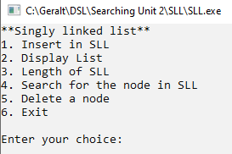
Enter Elements:

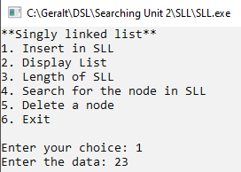
Display elements:
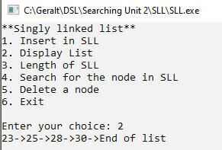
Length of list:
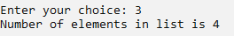
Search element:
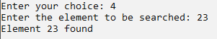
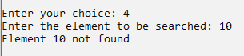

Head Node Deletion:
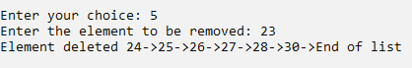
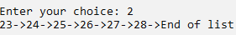
Tail Node Deletion:
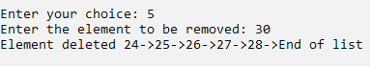
Any Node Deletion:
